MONTFORD FOOTBALL PROGRAM
“DIRTY DOZEN” SUMMER CONDITIONING
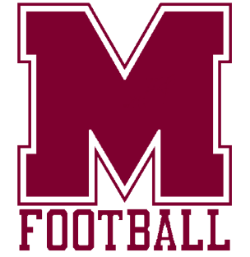
All workouts are voluntary. Participation in summer workouts does not guarantee any player with a spot on the final fall roster. All players must participate in fall tryouts prior to school starting to earn a spot on the team.
_______________________________________________________________
WHO: All rising 6th, 7th & 8th grade students zoned for Montford Middle School interested in trying out for the Montford Football Team in 2026. Homeschool students are welcome once their paperwork has been submitted to the Homeschool office and they have been cleared in Aktivate.
WHAT: Weight lifting and conditioning sessions to prepare for upcoming fall football tryouts.
WHERE: Montford gym weight room and football fields.
WHEN: Workouts will be Monday, Tuesday & Thursday mornings beginning at 8:30 and ending at 10:45 am. Students should arrive no earlier than 8:15 am and be picked up no later than 15 minutes following the conclusion of the day.
HOW: Workouts that include lifts and conditioning. Supervised instruction will be provided to teach proper form and safety on basic weight lifting movements that develop total body strength & power. Agility field drills that develop specific conditioning components will be at the core of the program.
WHY: To put each potential team member in the best possible physical and mental shape for tryouts.
WORKOUT DATES:
Week 1: June 22, 23 & 25 Week 3: July 6, 7 & 9. Week 2: June 29, 30 & July 2 Week 4: July 13, 14 & 16
ELIGIBILTY: All players are required by Leon County Schools to be fully cleared in the Aktivate Athlete Registration Platform BEFORE a student may participate.
Aktivate Information & Link can be found on the Montford Athletics Website. Paperwork should be scanned and uploaded to the Aktivate Portal System.
DRESS: Athletic shorts, t-shirt, tennis shoes, cleats and a personal water bottle are required at each practice. Water and ice will be provided by the program.

